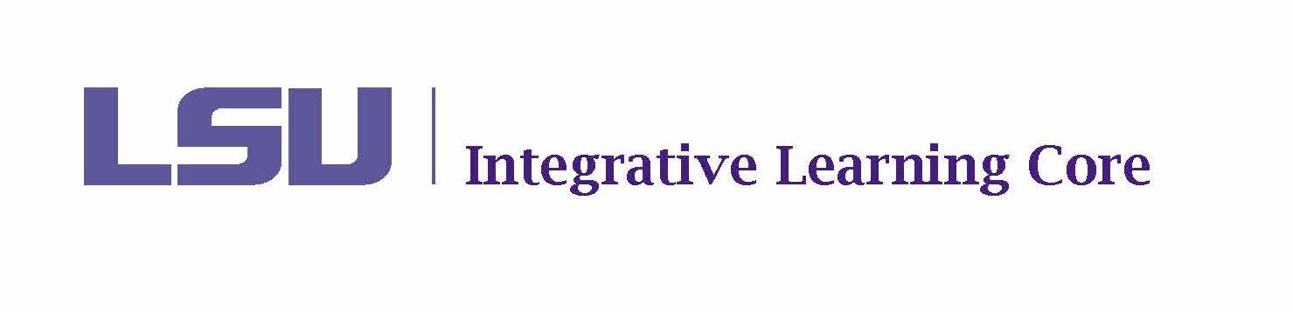

MEETING MINUTES

Faculty Senate Integrative Learning Core Committee

February 10, 2025

10:30-11:30am

Meeting Location: 135F Thomas Boyd Hall

Present: Aly Aly, Kayanush Aryana, David Chicoine (Co-Chair), Thomas Douthat, Ludovico Geymonat, Kyla Kazuschyk, William Ma, Selena Oswalt (Secretary), Jennifer Qian, Jason Wolfe (Co-Chair).

Ex-Officio Present: James Murphy, Haley Bourgeois, Tricia Cobb, Tachelle White

Agenda
- Call to Order – called to order at 10:34
- Roll Call and Introductions – quorum met; introductions made
- Public Comments on Agenda Items – none
- Discussion
- Voting
  - Minutes from November 18, 2024 – voted and approved (one abstention)
  - Election of Chair-Elect for 2024-2025 – Jason nominated as chair-elect; voted and approved unanimously
  - Course Renewals
    - POLI 2053 – Aly and Aryana – voted and approved unanimously
  - Course Proposals
    - CHEM 1005 – Oswalt and Qian – voted and approved unanimously
  - ILC Policy Updates (Renewals and Proposals) – This year we had 10 renewals in fall and 19 renewals for spring. For next year, all renewals will be sent out in the fall with a deadline of December 1. There is still a question about the start of academic year going forward. If summer starts academic year, that will change assessment reporting. Additionally, when a course is removed from the ILC list, it should not be allowed to be offered in the summer as an ILC course. Catalog for fall courses is published in March. Policy changes apply for summer, but curriculum changes are effective for fall. Tabled the vote on the ILC policy updates for now to confirm academic year and changes that would need to be made for renewals and reporting.

  - Removal of Courses
    - HIST 2022- “I was unable to teach this course in 2022-23 as I was on research leave. I am unable to teach it in 2023-4 owing to the department's need for me to teach two graduate courses instead (HIST 7923 and HIST 7908) and the need to teach two other ILC courses, HIST 2126 and HNRS 2408. Only I was available for those four courses, so I could not decline. I hope that another colleague will teach this course in 2024-5, as I will again be on research leave, thanks to a Guggenheim fellowship”. – voted and approved to remove (one abstention)
    - HNRS 2404- “The course is part of the new Honors Traditions in Critical Thought and Scholarship BA and will be routinely offered to those majors.” – no vote; decision to keep another year
    - PHYS 2401- The course has not been taught for the last two academic years. – never been offered; voted and approved to remove
- New Business
  - Course Renewals for Spring 2025 – being sent to coordinators today (2/10)
  - 2023-2024 ILC Assessment Reports – will be completed by the March meeting
  - Course Frequency (ref. POLI 2052) – requested a policy change. This is an honors course that also has a non-honors version. Since courses are not necessarily dropped, there is no need for policy change. Committee can opt to keep if appropriate justification is provided.

Meeting adjourned at 11:29. Next meeting set for 3/10.

*It is intended that public comments may be made (1) when they relate to a matter on the agenda and (2) when individuals desiring to make public comments have registered at least one hour prior to the meeting by emailing facultysenate@lsu.edu. When registering, individuals should identify themselves; the group they are representing, if appropriate; and the topic on which they would like to comment. To ensure that the meeting is conducted in an efficient manner, each individual will be limited to 3 minutes for their public comments and the President reserves the right to limit the total number of public comments if necessary.
The LSU Faculty Senate or its Committees may meet in executive session as authorized by La. R.S. 42:17.

